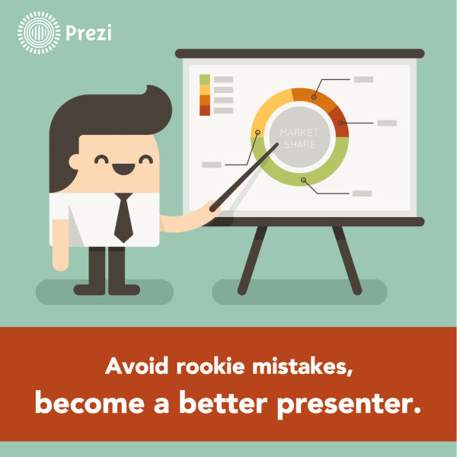
In this guest post, Terry Gault, Managing Partner and Vice President of The Henderson Group, provides insight into how to become a better presenter by avoiding a few common mistakes. Terry oversees all curriculum and services at The Henderson Group. In addition he is responsible for the selection, training and development of all trainers and facilitators for The Henderson Group, and has been an instructor with the Henderson Group for over 15 years.
Having coached clients on presentation skills since 1997, I’ve noticed some clear patterns in the behavior of inexperienced presenters.
Take a look at the prezi we've made to illustrate these 10 mistakes, and the easy ways that you can avoid them. What are your favorite tips for giving a great presentation? Add them in the comments below.
1. Using small scale movements and gestures.
Most rookie presenters are afraid to take up too much space. This hesitance comes across like an apology to the audience. For more on this topic, check out our post titled “What the heck do I do with my hands?!?"
2. Speaking with low energy.
Actually, this problem is not restricted solely to rookie presenters. 80 – 90% of the presenters that I observe do not expend enough energy. Hence, they come across as uninvolved, uninteresting, and unenthusiastic. Crank up the energy level! You will command more attention and project more confidence and charisma. I cannot stress this strongly enough. For more, check out our video on Speaking With Passion.
3. Not preparing enough
Granted, many rookie presenters don’t know how to prepare effectively other than preparing their media. Experienced speakers do plenty of research so that they feel confident in their material and their ability to respond to any question the audience might throw at them. They daydream about their topic even during ‘down time’ and often find the most creative ideas when doing other activities. I often come up with great ideas while driving, shopping, or running. It’s important to go through multiple drafts or iterations of your material, revising and editing, to arrive at the most finished form of your talk.
4. Not practicing enough
Not practicing your talks and presentations on your feet is one of the single biggest mistakes you can make. Experienced speakers will often do a dry run of their material with a trusted audience of friends, family, or colleagues. They will simulate the environment of their presentation using a projector and slide remote. They’ll choreograph their movements and gestures which will dramatically increase your ability to remember your material. They recognize areas of challenge (weak segues, awkward media transitions, etc.) and come up with tricks and tactics to help them flow seamlessly through their material.
5. Data centric presentations.
If your talk is focused on data rather than the vivid human story the data tells, you are in trouble. In the June 2013 issue of Fast Company magazine, Leslie Bradshaw, the COO of Guide is speaking about Big Data. She states: “The art is in preparing the content for optimal human consumption. The data doesn't just talk back to you. You collect, you analyze, you tell stories. Think of an iceberg. Underneath the waterline are data storage and analysis. Those are your engineers and scientists. Up above is the interface. It's both literal and narrative. It starts with the hard sciences–the math, the analytics–but it ends up with the softest: how to tell the story.”
6. Playing it safe.
Many presenters, rookies included, avoid taking risks. As my mentor and co-founder of our company often said, “Not taking a risk is also a risk.” When your presentation content is too safe, it usually comes across as boring. When the most important ability as a speaker is the ability to garner attention, can you afford to avoid taking risks?
7. Avoiding vulnerability.
This will seem very counter-intuitive to many young presenters but you must find ways to show vulnerability if you want to be seen as credible. If you are obviously trying to hard to seem perfect, savvy audiences will see through your act and become even more suspicious. Tells stories about times when you made dumb mistakes and then reveal what you learned. In Brene Brown’s talk on Vulnerabilty at TED, she states, “The original definition of courage, when it first came into the English language—it's from the Latin word cor, meaning heart—and the original definition was to tell the story of who you are with your whole heart… very simply, the courage to be imperfect.” For more on vulnerability, here are some related posts on our blog.
8. Taking oneself way too seriously.
Many speakers tend to be very serious and formal. If they could bring more of their natural, informal style into their presentations, they would be more authentic and engaging and authentic. The stiff formality and rigid “professionalism” many tend to slip into when presenting may garner respect but respect only has value if people actually want to spend time with you. If you defer too much to your audience, you are projecting that you are not of an equal stature. Respect the audience’s professionalism but relate to their humanity informally. By speaking to them more informally, you project that you are equal. They will read that as confidence. As I often say to clients, “If you are not having fun, you are not doing it right.”
9. Presenting too much material
Though it’s always better to have more material than you need, you also need to know what you will cut if you run out of time. Rookie presenters feel compelled to get through all their material even if it means going past their allotted time. I’ve heard of speakers who have gone as much as 45 minutes over their time commitment. This is inexcusable. If you want to estimate how much time your talk will actually take in front of an audience, practice on your feet and time yourself. Expect your actual talk will take at least 25% longer and maybe even 50%. Speakers often expand even further on their topic when they see audience’s reactions.
10. Rushing
Rushing further exacerbates any existing delivery or content problem you may already have. Phrases will lose impact because you are rushing. Slowing down will make you seem far more poised and confident and experienced. Using more pauses will also:
a) Increase audience perception as well as your feeling of confidence and ease.
b) Give your audience time to digest your key points and give those points greater impact.
c) Give you time to formulate your thoughts into more succinct and cogent sentences.
S-l-o-w d-o-w-n!

