Permaculture Principles
David Holmgren's Principles for Permaculture Design
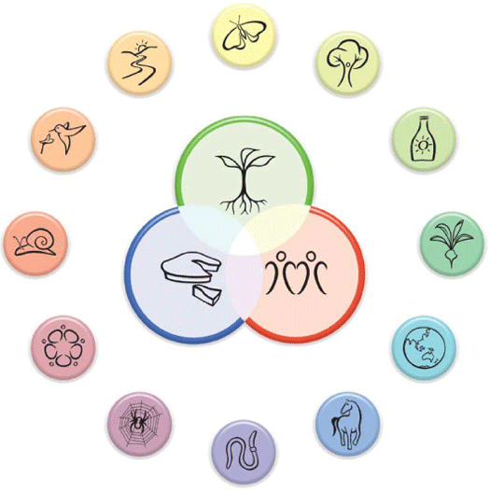
Principles are brief statements or slogans that can be remembered as a checklist when considering the complex options for design and evolution of ecological support systems. These principles can be seen as universal, although the methods that express them will vary greatly according to place and situation. Fundamentally, permaculture design principles arise from a way of perceiving the world that is often described as 'systems thinking' and 'design thinking.'
1. OBSERVE AND INTERACT
2. CAPTURE & STORE ENERGY
3. GET A YIELD
4. APPLY SELF-REGULATION & ACCEPT FEEDBACK
5. USE & VALUE RENEWABLE RESOURCES & SERVICES
6. PRODUCE NO WASTE
7. DESIGN FROM PATTERNS TO DETAILS
8. INTEGRATE RATHER THAN SEGREGATE
9. USE SMALL AND SLOW SOLUTIONS
10. USE AND VALUE DIVERSITY
11. USE EDGES AND VALUE THE MARGINAL
12. CREATIVELY USE AND RESPOND TO CHANGE
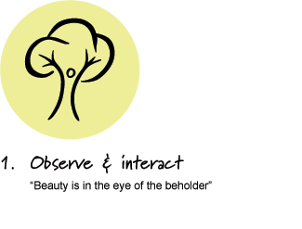
Principle 1: OBSERVE AND INTERACT
Good design depends on a free and harmonious relationship between nature and people, in which careful observation and thoughtful interaction provide the design inspiration, repertoire and patterns. It is not something that is generated in isolation, but through continuous and reciprocal interaction with the subject.
Within more conservative and socially bonded agrarian communities, the ability of some individuals to stand back from, observe and interpret both traditional and modern methods of land use, is a powerful tool in evolving new and more appropriate systems. While complete change within communities is always more difficult for a host of reasons, the presence of locally evolved models, with its roots in the best of traditional and modern ecological design, is more likely to be successful than a pre-designed system introduced from outside. Further, a diversity of such local models would naturally generate innovative elements which can cross-fertilise similar innovations elsewhere.
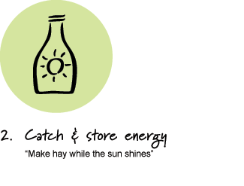
Principle 2: CATCH AND STORE ENERGY
We live in a world of unprecedented wealth resulting from the harvesting of the enormous storages of fossil fuels created by the earth over billions of years. We have used some of this wealth to increase our harvest of the Earth's renewable resources to an unsustainable degree. Most of the adverse impacts of this over-harvesting will show up as available fossil fuels decline. In financial language, we have been living by consuming global capital in a reckless manner that would send any business bankrupt.
Inappropriate concepts of wealth have led us to ignore opportunities to capture local flows of both renewable and non-renewable forms of energy. Identifying and acting on these opportunities can provide the energy with which we can rebuild capital, as well as provide us with an"income" for our immediate needs.
Some of the sources of energy include:
* Sun, wind and runoff water flows
* Wasted resources from agricultural, industrial and commercial activities
The most important storages of future value include:
* Fertile soil with high humus content
* Perennial vegetation systems, especially trees, yield food and other useful resources
* Water bodies and tanks
* Passive solar buildings
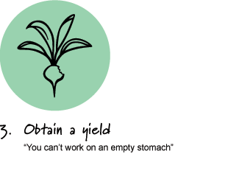
Principle 3: OBTAIN A YIELD
The previous principle focused our attention on the need to use existing wealth to make long-term investments in natural capital. But there is no point in attempting to plant a forest for the grandchildren if we haven't got enough to eat today.
This principle reminds us that we should design any system to provide for self-reliance at all levels (including ourselves), by using captured and stored energy effectively to maintain the system and capture more energy.
Without immediate and truly useful yields, whatever we design and develop will tend to wither while elements that do generate immediate yield will proliferate. Whether we attribute it to nature, market forces or human greed, systems that most effectively obtain a yield, and use it most effectively to meet the needs of survival, tend to prevail over alternatives.
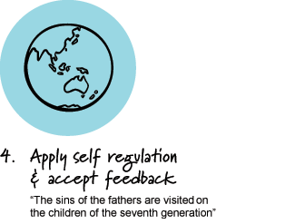
Principle 4: APPLY SELF-REGULATION AND ACCEPT FEEDBACK
This principle deals with self-regulatory aspects of permaculture design that limit or discourage inappropriate growth or behavior. With better understanding of how positive and negative feedbacks work in nature, we can design systems that are more self-regulating, thus reducing the work involved in repeated and harsh corrective management.
Self-maintaining and regulating systems might be said to be the 'Holy Grail' of permaculture: an ideal that we strive for but might never fully achieve. Much of this is achieved by application of the Integration and Diversity (Permaculture design principles 8 & 10) but it is also fostered by making each element within a system as self-reliant as is energy efficient. A system composed of self-reliant elements is more robust to disturbance. Use of tough, semi-wild and self-reproducing crop varieties and livestock breeds, instead of highly bred and dependent ones is a classic permaculture strategy that exemplifies this principle. On a larger scale, self-reliant farmers were once recognized as the basis of a strong and independent country. Today's globalize economies make for greater instability where effects cascade around the world. Rebuilding self-reliance at both the element and system level increases resilience.
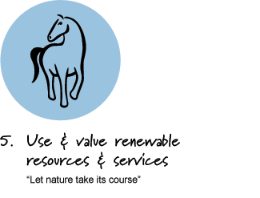
Principle 5: USE AND VALUE RENEWABLE RESOURCES AND SERVICES
Renewable resources are those that are renewed and replaced by natural processes over reasonable periods, without the need for major non-renewable inputs. In the language of business, renewable resources should be seen as our sources of income, while non-renewable resources can be thought of as capital assets. Spending our capital assets for day-to-day living is unsustainable in anyone's language. Permaculture design should aim to make best use of renewable natural resources to manage and maintain yields, even if some use of non-renewable resources is needed in establishing systems.
Renewable services (or passive functions) are those we gain from plants, animals and living soil and water, without them being consumed. For example, when we use a tree for wood we are using a renewable resource, but when we use a tree for shade and shelter, we gain benefits from the living tree that are non-consuming and require no harvesting energy. This simple understanding is obvious and yet powerful in redesigning systems where many simple functions have become dependent on non-renewable and unsustainable resource use.
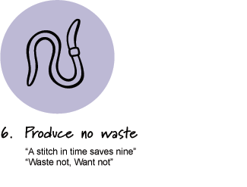
Principle 6: PRODUCE NO WASTE
This principle brings together traditional values of frugality and care for material goods, the modern concern about pollution, and the more radical perspective that sees wastes as resources and opportunities. The earthworm is a suitable icon for this principle because it lives by consuming plant litter (wastes), which it converts into humus that improves the soil environment for itself, for soil micro-organisms, and for the plants. Thus the earthworm, like all living things, is a part of a web where the outputs of one are the inputs for another.
The industrial processes that support modern life can be characterized by an input-output model, in which the inputs are natural materials and energy, while the outputs are useful things and services. However, when we step back from this process and take a long-term view, we can see all these useful things end up as wastes (mostly in rubbish tips) and that even the most ethereal of services required the degradation of energy and resources to wastes. This model might therefore be better characterized as "consume/excrete". The view of people as simply consumers and excreters might be biological, but it is not ecological.
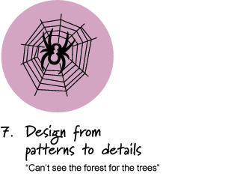
Principle 7: DESIGN FROM PATTERNS TO DETAILS
The first six principles tend to consider systems from the bottom-up perspective of elements, organisms, and individuals. The second six principles tend to emphasis the top-down perspective of the patterns and relationships that tend to emerge by system self-organization and co-evolution. The commonality of patterns observable in nature and society allows us to not only make sense of what we see, but to use a pattern from one context and scale, to design in another. Pattern recognition is an outcome of the application of Principle 1: Observe and interact, and is the necessary precursor to the process of design.
The idea which initiated permaculture was the forest as a model for agriculture. While not new, its lack of application and development across many bioregions and cultures was an opportunity to apply one of the most common ecosystem models to human land use. Although many critiques and limitations to the forest model need to be acknowledged, it remains a powerful example of pattern thinking which continues to inform permaculture and related concepts, such as forest gardening, agroforestry and analogue forestry.
The use of zones of intensity of use around an activity center such as a farmhouse to help in the placement of elements and subsystems is an example of working from pattern to details. Similarly environmental factors of sun, wind, flood, and fire can be arranged in sectors around the same focal point. These sectors have both a bioregional and a site specific character which the permaculture designer carries in their head to make sense of a site and help organize appropriate design elements into a workable system.
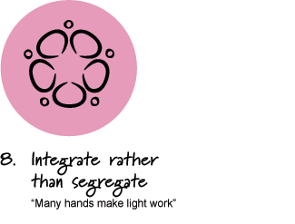
Principle 8: INTEGRATE RATHER THAN SEGREGATE
In every aspect of nature, from the internal workings of organisms to whole ecosystems, we find the connections between things are as important as the things themselves. Thus the purpose of a functional and self-regulating design is to place elements in such a way that each serves the needs and accepts the products of other elements.
This principle focuses more closely on the different types of relationships that draw elements together in more closely integrated systems, and on improved methods of designing communities of plants, animals and people to gain benefits from these relationships.
By correct placement of plants, animals, earthworks and other infrastructure it is possible to develop a higher degree of integration and self-regulation without the need for constant human input in corrective management. For example, the scratching of poultry under forage forests can be used to harvest litter to down slope garden systems by appropriate location. Herbaceous and woody weed species in animal pasture systems often contribute to soil improvement, biodiversity, medicinal and other special uses. Appropriate rotationally grazed livestock can often control these weedy species without eliminating them and their values completely.
In developing an awareness of the importance of relationships in the design of self-reliant systems, two statements in permaculture literature and teaching have been central:
1. Each element performs many functions.
2. Each important function is supported by many elements.
The connections or relationships between elements of an integrated system can vary greatly. Some may be predatory or competitive; others are co-operative, or even symbiotic. All these types of relationships can be beneficial in building a strong integrated system or community, but permaculture strongly emphasizes building mutually beneficial and symbiotic relationships. This is based on two beliefs:
1. We have a cultural disposition to see and believe in predatory and competitive relationships, and discount co-operative and symbiotic relationships, in nature and culture.
2. Co-operative and symbiotic relationships will be more adaptive in a future of declining energy.
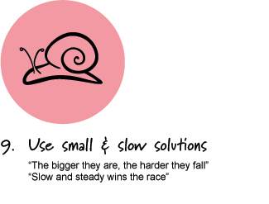
Principle 9: USE SMALL AND SLOW SOLUTIONS
Systems should be designed to perform functions at the smallest scale that is practical and energy-efficient for that function. Human scale and capacity should be the yardstick for a humane, democratic and sustainable society.
For example, in forestry, fast growing trees are often short lived, while some apparently slow growing but more valuable species accelerate and even surpass the fast species in their second and third decades. A small plantation of thinned and pruned trees can yield more total value than a large plantation without management.

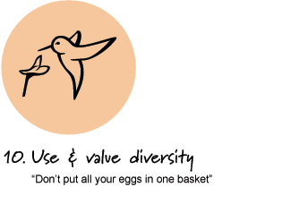
Principle 10: USE AND VALUE DIVERSITY
The great diversity of forms, functions and interactions in nature and humanity are the source of evolved systemic complexity. The role and value of diversity in nature, culture and permaculture is itself complex, dynamic, and at times apparently contradictory. Diversity needs to be seen as a result of the balance and tension in nature between variety and possibility on the one hand, and productivity and power on the other.
It is now widely recognized that monoculture is a major cause of vulnerability to pests and diseases, and therefore of the widespread use of toxic chemicals and energy to control these. Polyculture (the cultivation of many plant and/or animal species and varieties within an integrated system) is one of the most important and widely recognized applications of the use of diversity to reduce vulnerability to pests, adverse seasons and market fluctuations. Polyculture also reduces reliance on market systems, and bolsters household and community self-reliance by providing a wider range of goods and services.
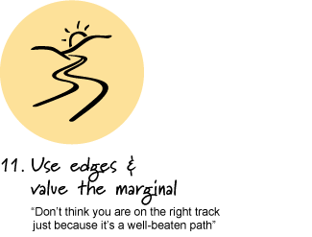
Principle 11: USE EDGES AND VALUE THE MARGINAL
Tidal estuaries are a complex interface between land and sea that can be seen as a great ecological trade market between these two great domains of life. The shallow water allows penetration of sunlight for algae and plant growth, as well as providing forage areas for wading and other birds. The fresh water from catchment streams rides over the heavier saline water that pulses back and forth with the daily tides, redistributing nutrients and food for the teeming life.
Within every terrestrial ecosystem, the living soil, which may only be a few centimeters deep, is an edge or interface between non-living mineral earth and the atmosphere. For all terrestrial life, including humanity, this is the most important edge of all. Only a limited number of hardy species can thrive in shallow, compacted and poorly drained soil, which has insufficient interface. Deep, well-drained and aerated soil is like a sponge, a great interface that supports productive and healthy plant life.
This principle works from the premise that the value and contribution of edges, and the marginal and invisible aspects of any system should not only be recognized and conserved, but that expansion of these aspects can increase system productivity and stability. For example, increasing the edge between field and pond can increase the productivity of both. Alley farming and shelterbelt forestry can be seen as systems where increasing edge between field and forest has contributed to productivity.
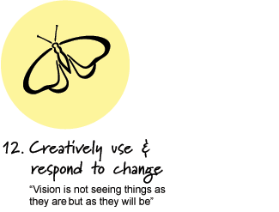
Principle 12: CREATIVELY USE AND RESPOND TO CHANGE
Permaculture is about the durability of natural living systems and human culture, but this durability paradoxically depends in large measure on flexibility and change. Many stories and traditions have the theme that within the greatest stability lie the seeds of change. Science has shown us that the apparently solid and permanent is, at the cellular and atomic level, a seething mass of energy and change, similar to the descriptions in various spiritual traditions.
The acceleration of ecological succession within cultivated systems is the most common expression of this principle in permaculture literature and practice, and illustrates the first thread. For example, the use of fast growing nitrogen fixing trees to improve soil, and to provide shelter and shade for more valuable slow growing food trees, reflects an ecological succession process from pioneers to climax. The progressive removal of some or all of the nitrogen fixers for fodder and fuel as the tree crop system matures shows the success. The seed in the soil capable of regeneration after natural disaster or land use change (e.g. to an annual crop phase) provides the insurance to re-establish the system in the future.

The Principles of Permaculture Design (Mollison):
Whereas permaculture ethics are more akin to broad moral values or codes of behavior, the principles of permaculture provide a set of universally applicable guidelines which can be used in designing sustainable habitats. Distilled from multiple disciplines–ecology, energy conservation, landscape design, and environmental science–these principles are inherent in any permaculture design, in any climate, and at any scale. The following is a list of these principles.
1. Relative Location: Components placed in a system are viewed relatively, not in isolation.
2. Functional Relationship between components: Everything is connected to everything else.
3. Recognize functional relationships between elements: Every function is supported by many elements.
4. Redundancy: Good design ensures that all important functions can withstand the failure of one or more element. Design backups.
5. Every element is supported by many functions: Each element we include is a system, chosen and placed so that it performs as many functions as possible.
6. Local Focus: "Think globally - Act locally" Grow your own food, cooperate with neighbors. Community efficiency not self-sufficiency.
7. Diversity: As a general rule, as sustainable systems mature they become increasingly diverse in both space and time. What is important is the complexity of the functional relationships that exist between elements not the number of elements.
8. Use Biological Resources: We know living things reproduce and build up their availability over time, assisted by their interaction with other compatible elements. Use and reserve biological intelligence.
9. One Calorie In/One Calorie Out: Do not consume or export more biomass than carbon fixed by the solar budget.
10. Stocking: Finding the balance of various elements to keep one from overpowering another over time. How much of an element needs to be produced in order to fulfill the need of whole system?
11. Stacking: Multilevel functions for single element (stacking functions). Multilevel garden design, i.e., trellising, forest garden, vines, groundcovers, etc.
12. Succession: Recognize that certain elements prepare the way for systems to support other elements in the future, i.e.: succession planting.
13. Use Onsite Resources: Determine what resources are available and entering the system on their own and maximize their use.
14. Edge Effect: Ecotones are the most diverse and fertile area in a system. Two ecosystems come together to form a third which has more diversity than either of the other two, i.e.: edges of ponds, forests, meadows, currents etc.
15. Energy Recycling: Yields from system designed to supply onsite needs and/or needs of local region.
16. Small Scale: Intensive Systems start small and create a system that is manageable and produces a high yield.
17. Make Least Change for the Greatest Effect: The less change that is generated, the less embedded energy is used to endow the system.
18. Planting Strategy: 1st-natives, 2nd-proven exotics, 3rd unproven exotics - carefully on small scale with lots of observation.
19. Work Within Nature: Aiding the natural cycles results in higher yield and less work. A little support goes a long way.
20. Appropriate Technology: The same principles apply to cooking, lighting, transportation, heating, sewage treatment, water and other utilities.
21. Law of Return: Whatever we take, we must return Every object must responsibly provide for its replacement.
22. Stress and Harmony: Stress here may be defined as either prevention of natural function, or of forced function. Harmony may be defined as the integration of chosen and natural functions, and the easy supply of essential needs.
23. The Problem is the solution: We are the problem, we are the solution. Turn constraints into resources. Mistakes are tools for learning.
24. The yield of a system is theoretically unlimited: The only limit on the number of uses of a resource possible is the limit of information and imagination of designer.
25. Dispersal of Yield Over Time: Principal of seven generations. We can use energy to construct these systems, providing that in their lifetime, they store or conserve more energy that we use to construct them or to maintain them.
26. A Policy of Responsibility (to relinquish power): The role of successful design is to create a self-managed system.
27. Principle of Disorder: Order and harmony produce energy for other uses. Disorder consumes energy to no useful end. Tidiness is maintained disorder. Chaos has form, but is not predictable. The amplification of small fluctuations.
28. Entropy: In complex systems, disorder is an increasing result. Entropy and life-force are a stable pair that maintain the universe to infinity.
29. Metastability: For a complex system to remain stable, there must be small pockets of disorder.
30. Entelechy: Principal of genetic intelligence. i.e. The rose has thorns to protect itself.
31. Observation: Protracted & thoughtful observation rather than protracted and thoughtless labor.
32. We are surrounded by insurmountable opportunities.
33. Wait one year: (See #31, above)
34. Hold water and fertility as high (in elevation) on the landscape as possible. Its all downhill from there.

